Kevin Barrett, Geography 523

Winkler, M.G. 1985. Late-glacial and Holocene environmental history of south-central Wisconsin: a study of upland and wetland ecosystems. Dissertation. University of Wisconsin, Madison, Wisconsin, USA.

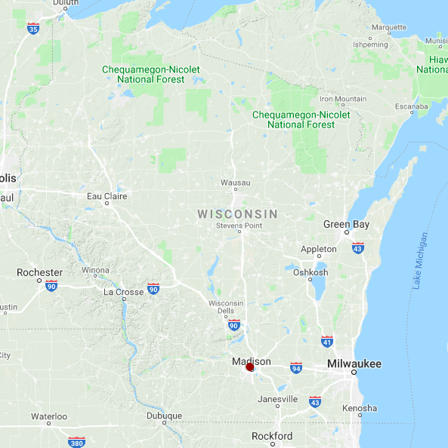

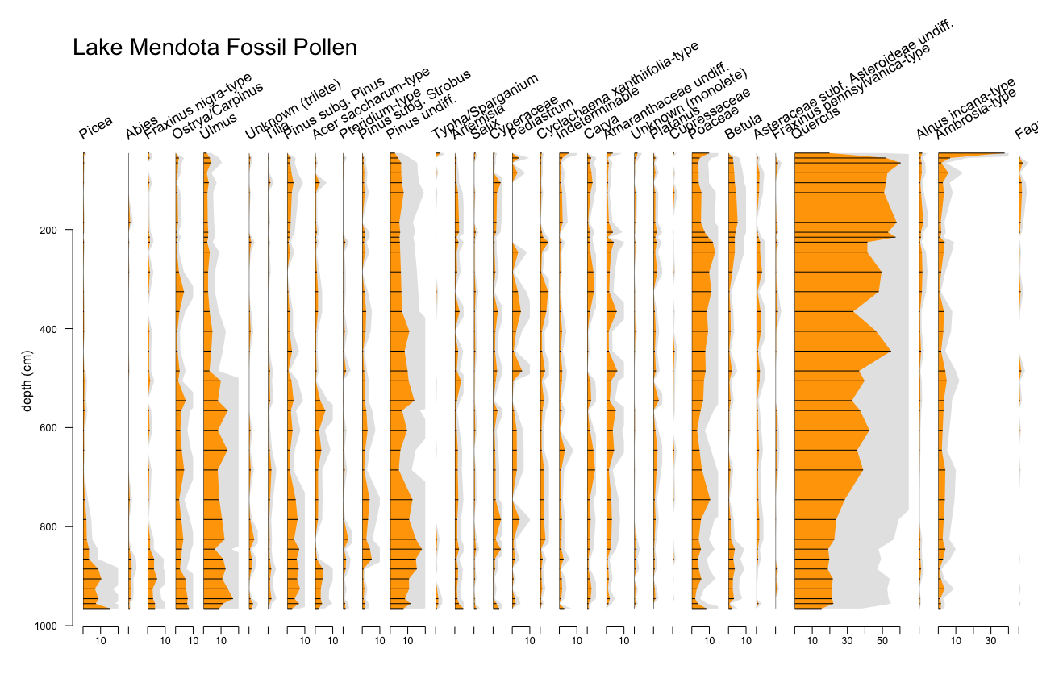

Code:

############### Install rioja

library("rioja")

############### Importing data

## Read csv file

mendota <- read.csv("LAke Mendota Fossil Pollen.csv")

class(mendota) # dataset type = data.frame

typeof(mendota) # vector type = list

################ selecting only pollen dataset

rm.row <- c(1:6)

rm.col <- c(1:5)

mendota.pollen <- mendota[-rm.row,-rm.col] # selecting only pollen dataset

mendota.pollen <- t(mendota.pollen) # transpose

mendota.pollen

class(mendota.pollen) # dataset type = matrix

typeof(mendota.pollen) # vector type = character

mendota.pollen <- matrix(sapply(mendota.pollen,as.numeric),ncol=70,nrow=34) # change character matrix to numeric matrix

mendota.pollen[is.na(mendota.pollen)] <- 0 ## Convert NA to 0

mendota.pollen <- as.data.frame(mendota.pollen) ## DATA FRAME

################# taxa column names

taxa.name <- as.character(mendota[,1])

taxa.name <- taxa.name[-c(1:6)]

colnames(mendota.pollen) <- taxa.name

rownames(mendota.pollen) <- seq(1,length(rownames(mendota.pollen)),1)

hawaii.pollen <- hawaii.pollen[,-38] # Remove Lycopodium Spike column

################## Pollen abundance (%)

mendota.pollen.cont <- round(mendota.pollen/rowSums(mendota.pollen[1:70]), digit=3)*100

head(mendota.pollen.cont)

################## Adding depth to rownames

depth <- as.numeric(as.vector(unlist(mendota[2,seq(6,39,1)])))

rownames(mendota.pollen.cont) <- depth

head(mendota.pollen.cont)

################## Pollen diagram with all taxa

strat.plot(mendota.pollen.cont, scale.percent = TRUE, yvar=depth,y.rev=TRUE,

wa.order = "bottomleft",ylabel="depth (cm)")

################## Subset taxa with the pollen sum more than 10% over depth + pollen diagram

pollen.sum <- colSums(mendota.pollen.cont) # Column sums

mendota.pollen.trim <- mendota.pollen.cont[,which(pollen.sum>10)] # Subset

strat.plot(mendota.pollen.trim, scale.percent = TRUE, yvar=depth, y.rev=TRUE,

wa.order = "bottomleft",ylabel="depth (cm)") # pollen diagram

################## Filled pollen diagram: subset taxa, exaggeration

## Orange filled pollen diagram with 2.5X exaggeration

strat.plot(mendota.pollen.trim, scale.percent=TRUE, yvar=depth,y.rev=TRUE,

wa.order="bottomleft", col.line = "black", ylabel="depth (cm)", xlabel="relative abundance", srt.xlabel=30, title="Lake Mendota Fossil Pollen",

plot.bar=TRUE, col.bar="black", plot.poly=TRUE, col.poly = "orange", exag=TRUE, exag.mult=2.5, col.exag="grey90")